Brooke Williams | Titled APA Physiotherapist 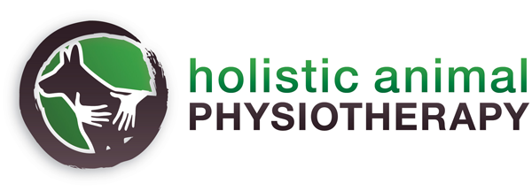
Masters Animal Studies (Physiotherapy) 2005 (MAnimST) www.holisticanimalphysio.com.au
Bachelor Physiotherapy (BPHTY, 1997). Ph: 0408 022 660
Graduate Diploma in Veterinary Acupuncture (GDVA). Email: reception@holisticanimalphysio.com.au
Member Australian Physiotherapy Association. ABN 35627818875

INITIAL TREATMENT FORM
Owner Details | Patient Details
Owner’s Name: | Animal’s Name:
Work Phone: | Species:
Home Phone: | Age: | Sex:
Mobile: | Breed:
Address:

What is your reason for seeking out our services? Ie. what is your pet's main problem? (a brief explanation is fine)
What are your goals to achieve in this session?
What times/days are you available for an appointment?

What does your pet respond best to (e.g. treats, affection)?

Does your pet have any allergies?
How is your pet with other animals? (We endeavor to not have any animals meet each other in the clinic)

How is your pet with people? Is there anything we need to know from a safety perspective in handling your pet? If your pet requires a muzzle and you have one properly fitted, please bring it with you. Please ensure that your dog has a proper fitting collar or harness that doesn’t pull over their head, this is for safety reasons and that your animal is on lead or in a carrier (for a cat) to attend the sessions.

How did you hear about our services?

If there is anything else we need to know to help this session be as stress-free and beneficial as possible please let us know

Referring Veterinarian
Name:
Veterinary Practice:
Address:
Phone: | Email:

Please be aware due to high demand we require 24hr notice for cancellation or a full appointment fee may apply. This enables us to treat other animals on our waitlist. Thank you for your understanding. You will receive a courtesy auto SMS reminder 7am the day prior if you can please reply for all your appointments with a ‘Y’ to confirm. If we have not received this by 12pm we may need to offer this appointment to someone in need on the waitlist. We appreciate your co-operation with this.

Thank you for trusting us with the care of your pet! We look forward to meeting you all.
We will contact you shortly to discuss an appointment time.

Holistic Animal Physiotherapy
Email: reception@holisiticanimalphysio.com.au

